Chris Huntley

Black Shell Consulting  Fort Worth/San Francisco

Using PowerBI with LinkedIn data for some analysis

Table of Contents

Get The Data 2

Get Working Files 5

Transform 6

PowerBI 10

Get Custom Visuals 12

Extra Steps 13

Make a Chart 14

Example of Finished Dashboard 15

**Get the Data.**

Download your linked in data.

Go to your profile picture right click and choose settings and privacy

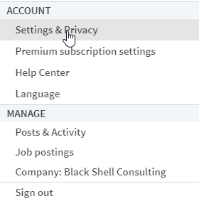

Scroll down to download your data

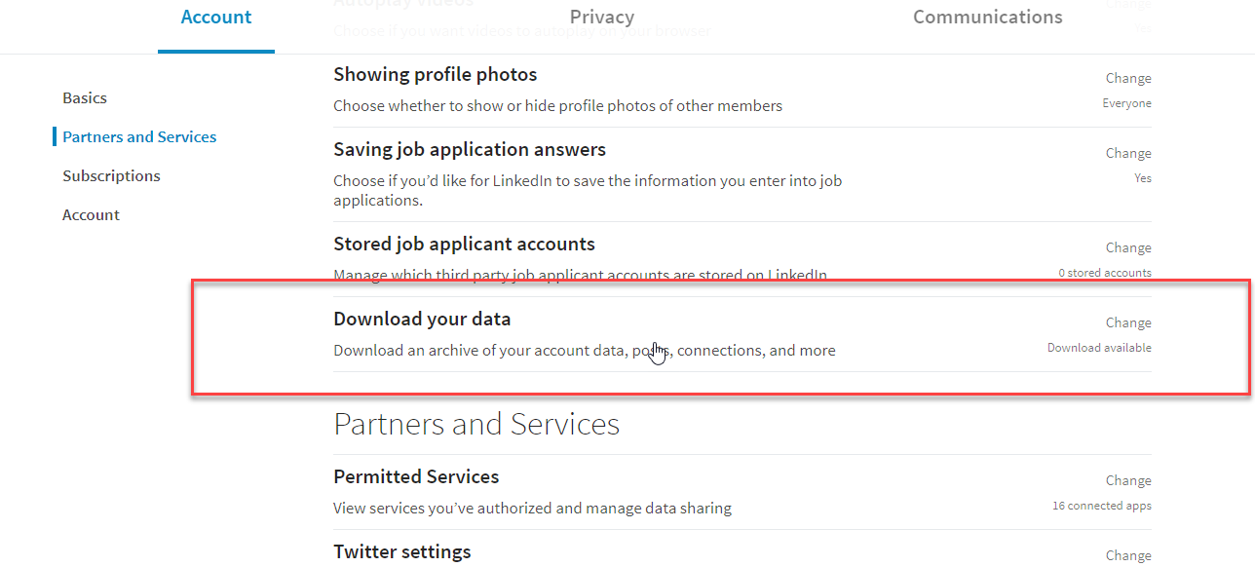

Choose what you want to download. I’d choose everything as we’ll look at it in various future tutorials but at a minimum download connections for this tutorial.

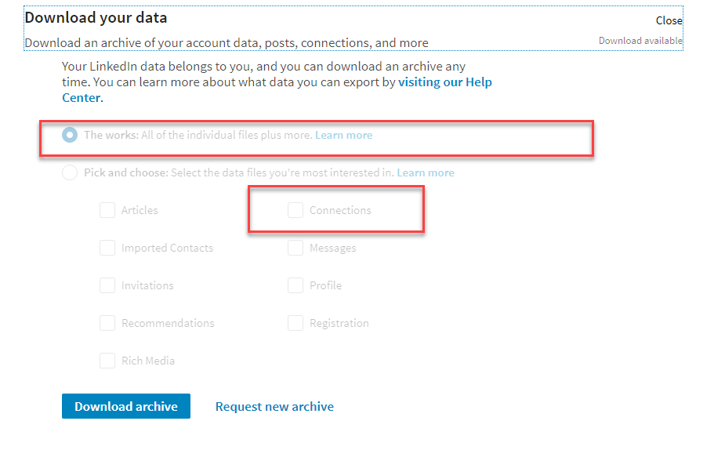

It takes around 24 hours to get the data so once you get here set a reminder to come back and finish it.

Once you get the files extract them to somewhere you can access them.   
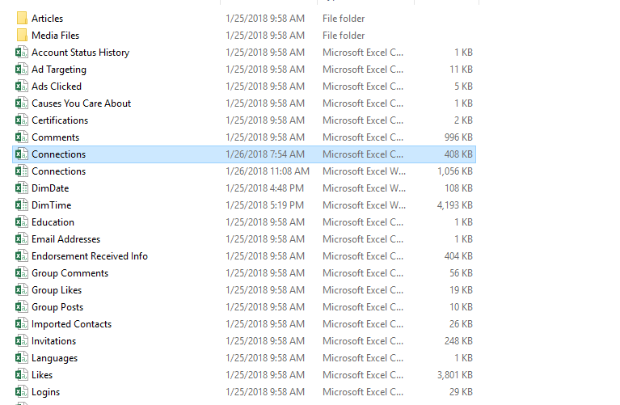

**Get the working files**

For the tutorial you’ll need two additional files for dimensional pivoting. They’re called DimDate and DimTime. You can create your own Date Dimension and Time Dimension but to make it easy I did it for you. The files are here on the github. You can download them, clone or fork the repository. It’s all open for your using and licensed appropriately.

Repo: <https://github.com/Huntleychris/LinkedInConnections>

You need the ones shown in the red boxes.

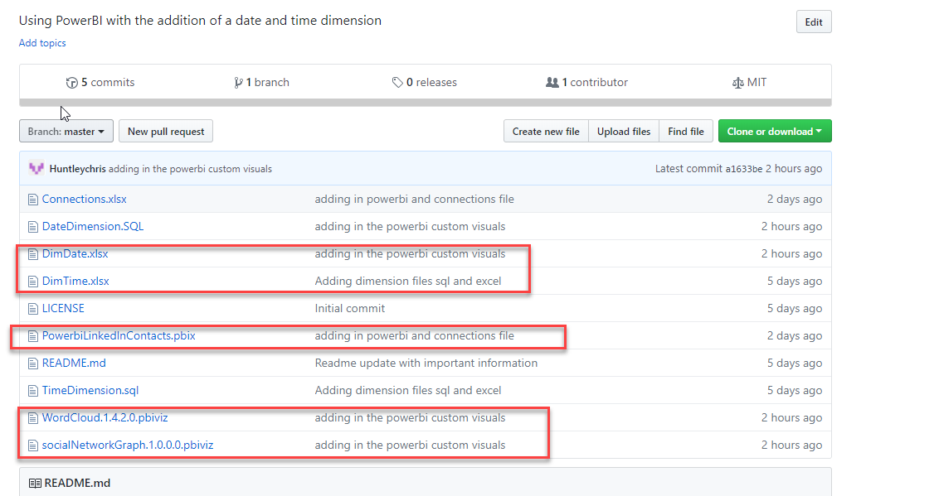

**Transform the Data**

Let’s open the connections file and make a couple of changes in order to get it connected properly with the dimensions.

The files come as .CSV (comma separated values) so import them into excel. Simply opening them has given me some trouble with a comma being added to the datetime but your mileage may vary.

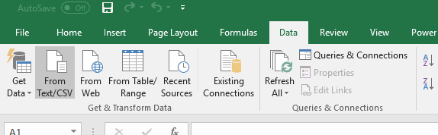

Before you begin remove the table formatting from this worksheet. It’s not necessary and it’s going to give you issues later.

Left click in the table area and it will activate the table tools. Click on design.

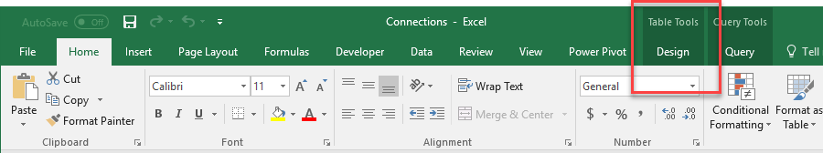

Click convert to range.

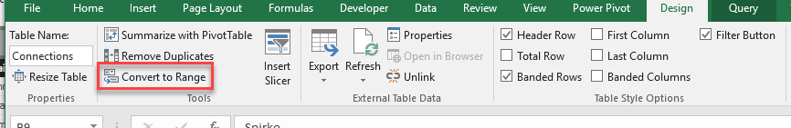

Now you can add columns without issues.

Next copy the Connected On Column twice and paste just the values ,do this in column H and I. Label one Date and One Time. Add a third label of SecondsKey in Column J (this matters for the formula later). The SecondsKey is the connection to the time dimension.

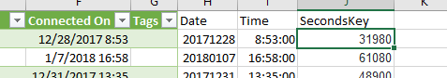

Format the Date column as date

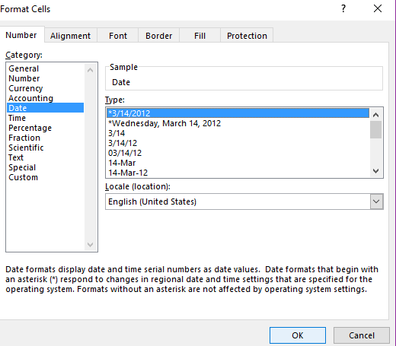

Then format it as YYYYMMDD as shown

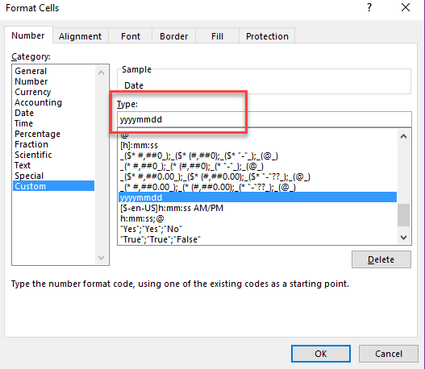

If you don’t have the option yyyymmdd then just type it in the type box highlighted with the red square.

This has proven to be a headache for some people do the alternative is to use this formula

=TEXT((H21,"YYYYMMDD")

That will get the date into a text column and the proper format for the joining.

Now format the time as shown:

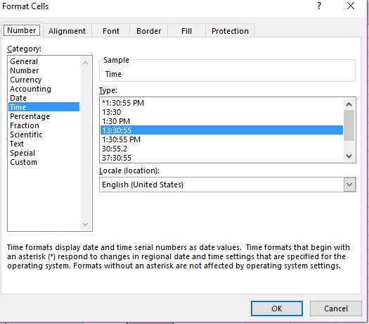

The formula to get second of the date is:

=HOUR(I2)*3600+MINUTE(I2)*60+SECOND(I2)

Just fill the formula and you’ll have the seconds.

**Now copy the SecondsKey Column and Date Column and paste them as values only.**

This will make it much easier when it’s imported

Now save it and you’re ready to get into PowerBI.

PowerBI

If you don’t have it get the desktop here: [PowerBI Desktop](https://powerbi.microsoft.com/en-us/desktop/) (<https://powerbi.microsoft.com/en-us/desktop/>) it’s free for this purpose so no worries.

Grab the premade file I loaded to the git repository or create it yourself.

In the premade the relationships are already created and the dimensions are already existing.

If you want to update the files with the ones you pulled yourself all you have to do is:

Choose Edit Queries

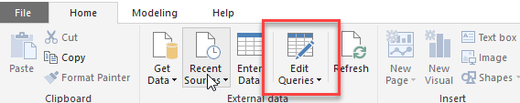

Change Data Source Settings.

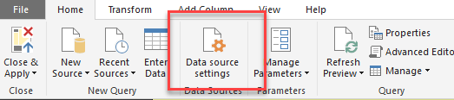

Change the paths to where you put the files

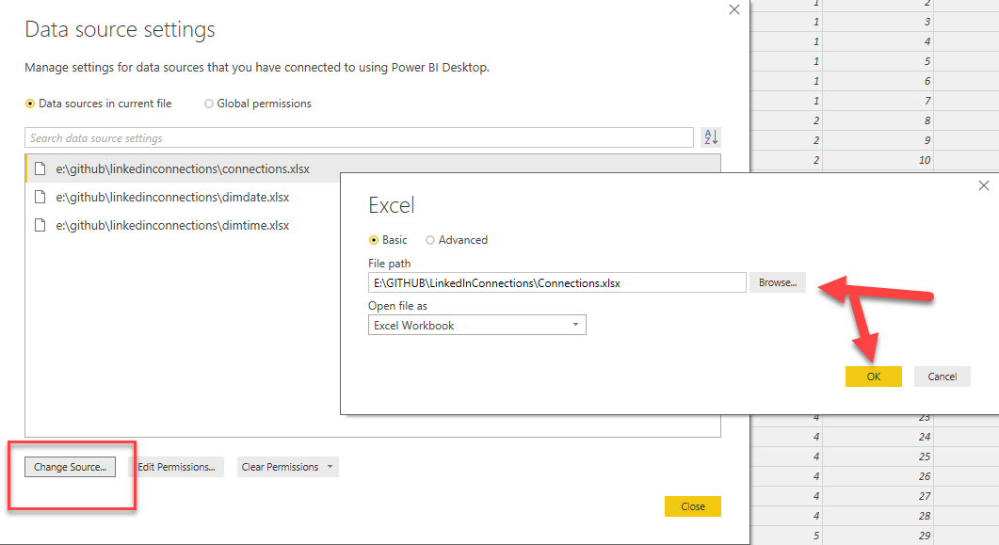

Close and apply

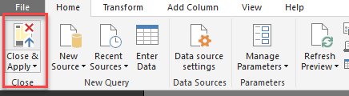

Refresh if it’s not already up to date.

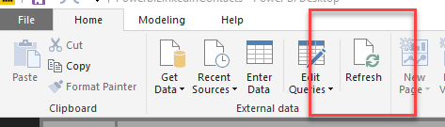

**Custom Visuals**

Now get custom visuals.

https://appsource.microsoft.com/en-us/marketplace/apps?product=power-bi-visuals&page=1

One I used was the word cloud:

I also pulled in the social graph but that’s for another day. Regardless it’s in the files.

Install them from files by clicking the ellipsis and import from file.

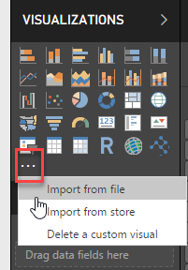

**Extra Steps**

I wanted to go a little farther with the analysis so I’m going to extract the email domain to see who is using what domain in my contacts.

Reopen the connections excel spreadsheet and enter the following formula in a new column titled domain:

=RIGHT(C2,LEN(C2)-FIND("@",C2))

Reimport the data by clicking Edit Queries

Then Refreshing the data to make sure you have a domains column

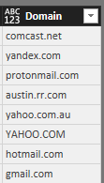

**Make a chart**

I’m going to use the Domain and make a donut chart

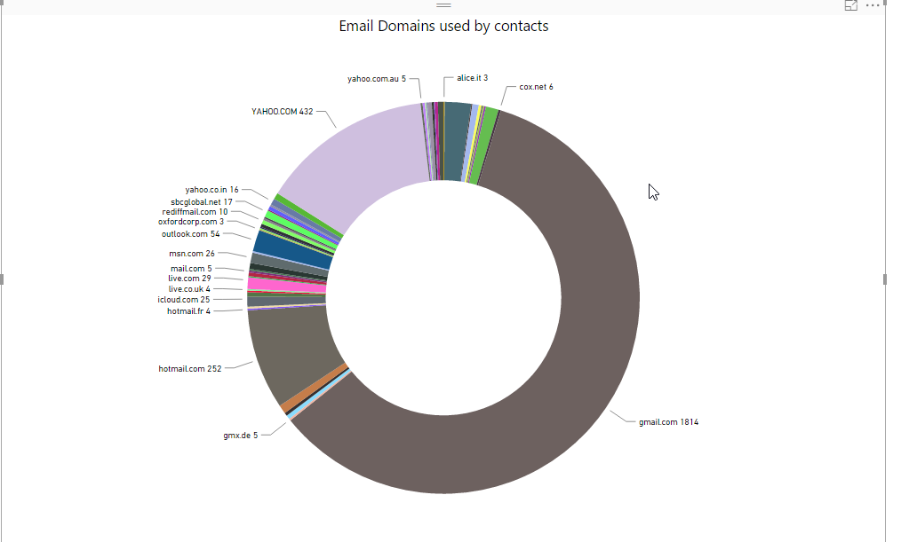

Drag the column Domain into the details section

Now click the donut chart above the legend text. It’s got a yellow box around it below.

Last Drag the Column domain into the values section. Set it to be counted or use a percentage. Up to you.

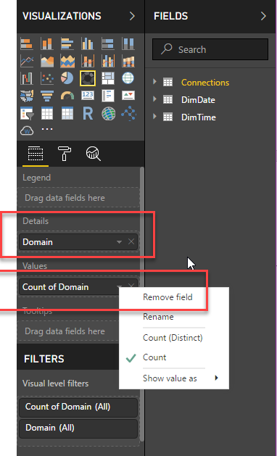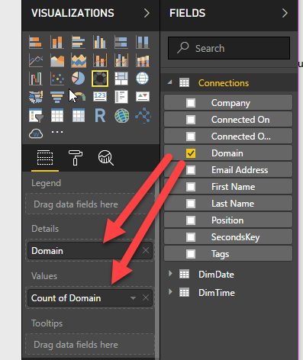

See what you can do.

Here’s what I came up with and my analysis says I really just started using LinkedIn appropriately and I probably need to get off at some point in the day.

Example

